Circles

I gave my friend a circle and asked on bended knee
If she would thrill my heart and marry me
In that very special moment I’m sure that you can guess
My happiness and wonder when my friend said “Yes!”

I gave to my fiancée a circle newly blest
And proudly before God my love confessed
We shared two little circles with promises for life
And walked together hand in hand as Husband and Wife
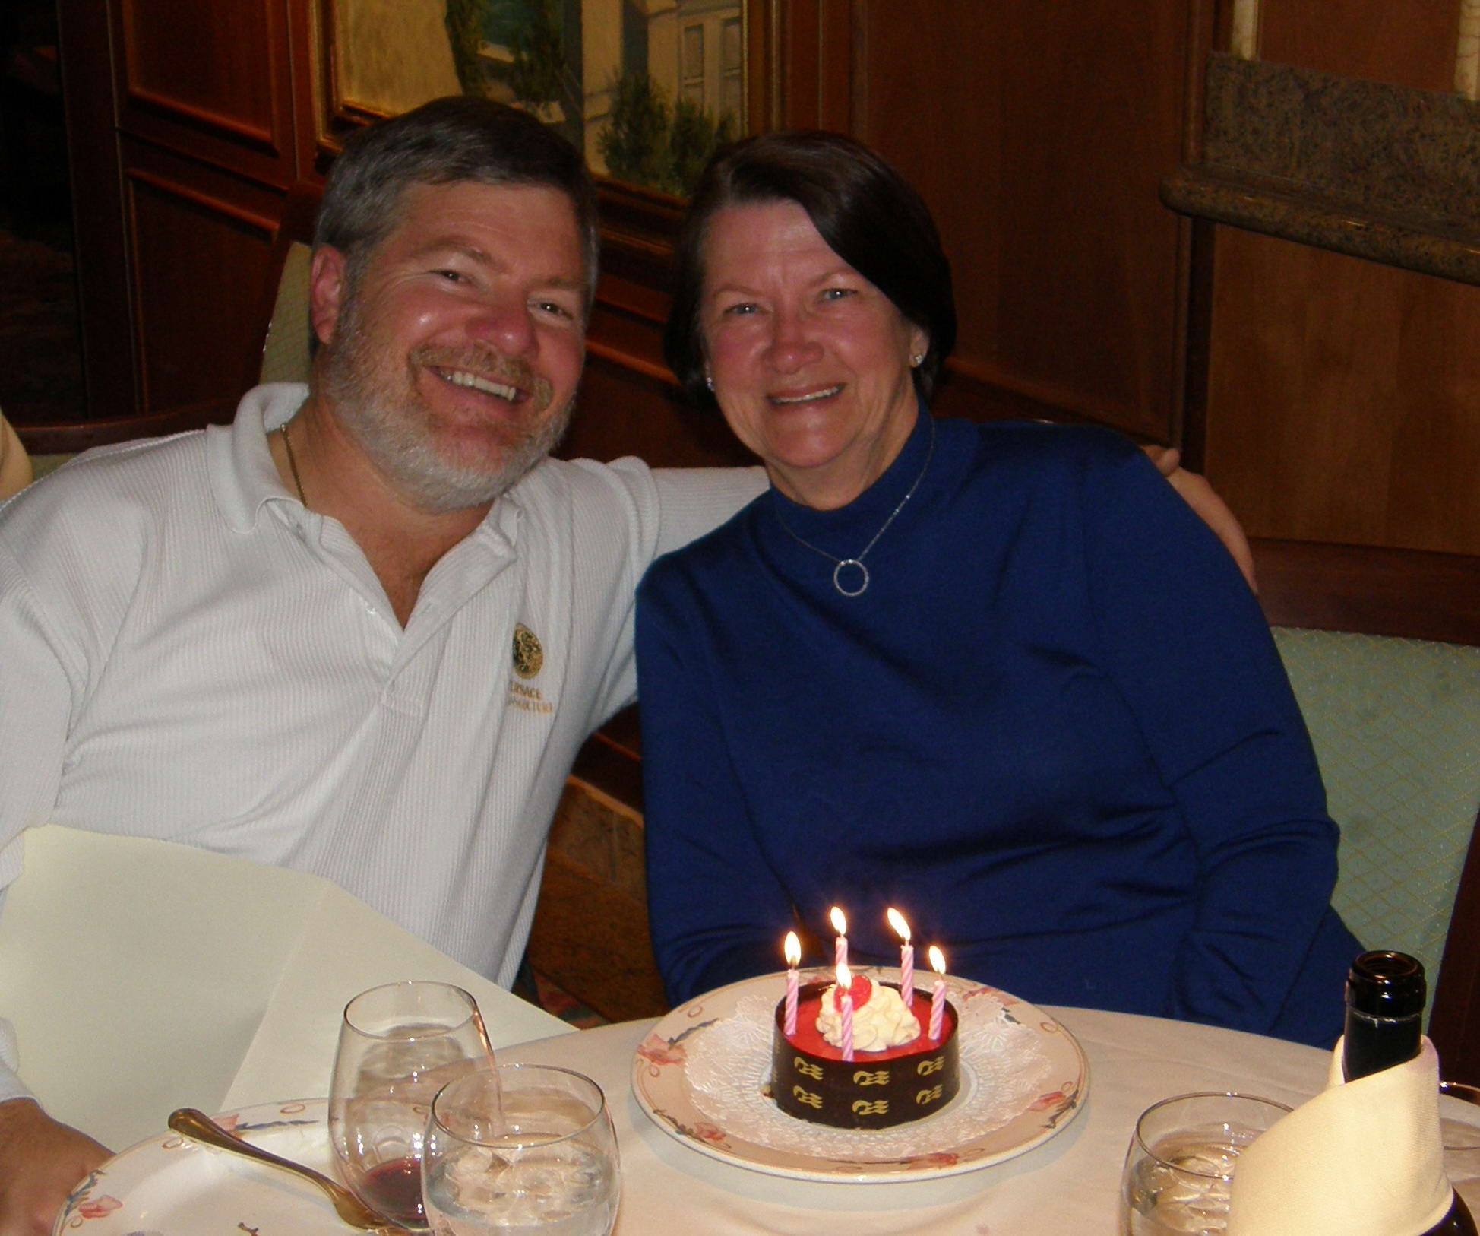

A third and sparkled circle I gave, my love, to thee
To witness to our love’s eternity
These circles worn together reflecting sparkled light
Speak proudly to the universe of love’s delight

And now this special circle, I give to you my wife
That witnesses the pattern of our life
Each tiny special sparkle, that shines so brilliantly
Reflects the light and joy that your love brings to me

