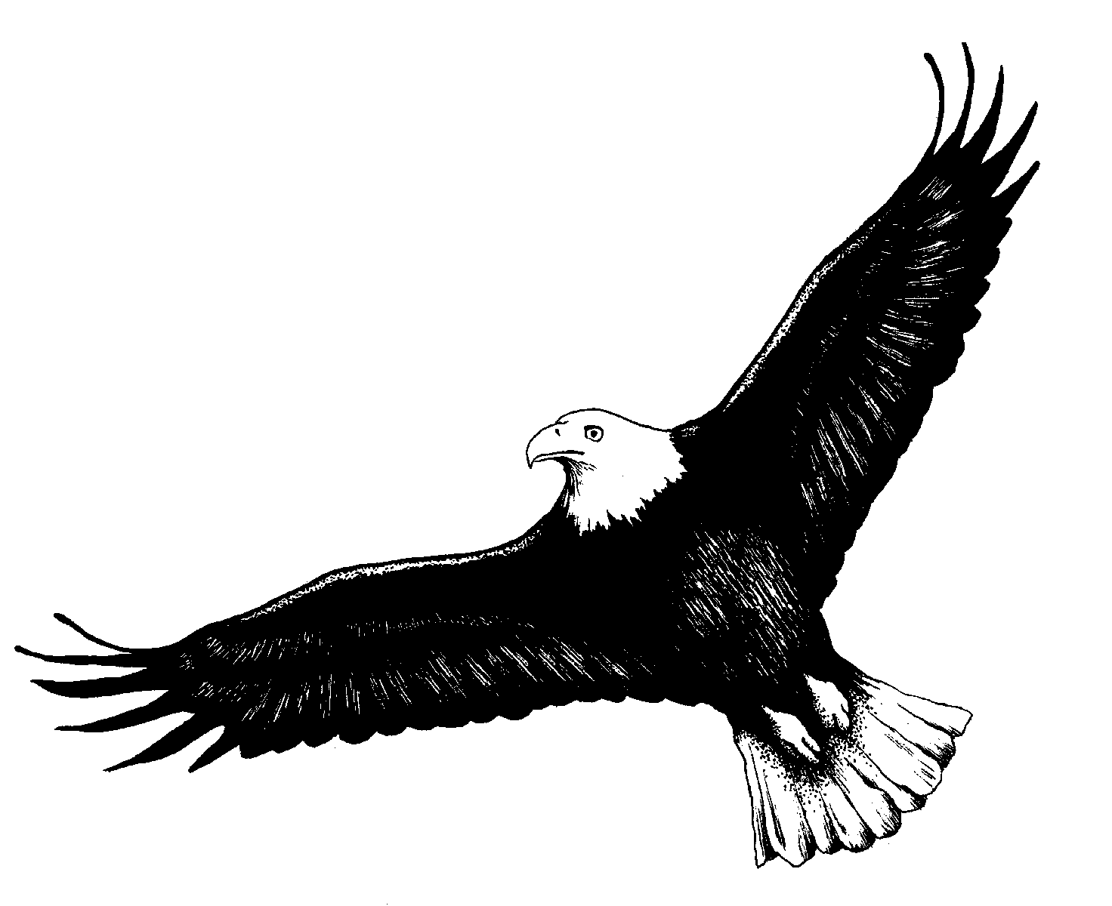
On Eagles’ Wings

Have you seen the eagle fly so stately blithe and free
Carried by the slightest wind for near eternity?
Graceful, proud, commanding, strong as o'er the land she flies
Powerfully aware of her supremacy of skies.

Have you heard the parable of how she learns to fly?
Do you know the way she gains this lordship of the sky?
When her time is right her mother takes her from her rest
She takes her chick and drops her from her safe home aerie nest.

The frightened chick it does its best to slow its fast descent
So new, unsure it flaps with might till all its strength is spent
And just before it seems to lose its bargain with the sky
It’s caught upon its mother’s wings and taken back on high.

O'er and o'er this game of stealth and art is played at will
Each new time the frightened chick discovers strength and skill
Till comes the time when mother's watchful eye regards with pride
No further need to catch her charge as on the winds she rides.

So necessary each time she'd been the vehicle of love
So necessary to catch her chick and take her back above
But now her care has brought to birth a freedom new unfurled
She sees her charge has come of age in strength to face the world.

Oh fly upon the winds with joy be proud and strong and true.
Fly with thanks remembering the love revealed to you.
Love and wisdom, stern and strong, unyielding in its quest
To bring to birth in those it loves the best – the very best!

You can see this parable enacted through life’s days
You can see this love proclaimed in life’s grand myriad ways
Yes proud we fly for when we fall, in faith our spirit sings
In sureness of the One who catches us upon His wings.

